GPS-based power theft detection and alert system

using GSM
Pavithra K N¹, Darwin Nesakumar A², Vishal P V³, Tarunkumar S⁴, Vedantamurthy B⁵, Tharani R⁶
¹Department of Computer Science and Engineering, 2,3,4, 5,6Department of Electronics and Communication Engineering,
¹R.M.D. Engineering College, ^{2,3,4,5,6}R.M.K. Engineering College

Corresponding Author: adn.ece@rmkec.ac.in

Abstract: The illegal act of stealing electrical power is known as the theft of electricity. A loss not only to an individual but also to society and the nation as a whole is the theft of electricity. Theft of electricity is a significant and growing global issue. India is one of many developing nations where electricity theft is a problem. The electrical power theft detection system is used to find unauthorized tapping on distribution lines. Meter tampering, unauthorized connections, and unpaid bills are all examples of electricity theft. The execution region of this framework is at appropriation organization of the electrical power supply framework. The government and the Electricity Companies have always had trouble carrying out their power theft activities. It addresses all of these issues by utilizing a straightforward device to send a message whenever power theft occurs in a specific location. It will safeguard the dispersion network from power burglary done in specific regions.

Keywords: AMI, RNN Network, GSM Module, GPS, ETD(Electricity theft detection)

I. INTRODUCTION
Because advanced metering infrastructure (AMI) is one of the most important parts of the smart grid, it gives you a lot of data. This makes technologies like data mining better for detecting electricity theft. However, many AI-based techniques, such as deep learning, are susceptible to under- fitting due to the unbalanced data set in the field of electricity theft. In this study, an outlier detection method based on clustering and the local outlier factor (LOF) is proposed to evade this issue and detect as many types of theft attacks as possible. Using k-means, we first look at the load profiles. The outlier candidates are then customers whose load profiles are far from the cluster centers. After that, the LOF is used to determine the outlier candidates' anomaly degrees. It is then intended to Compare the system for the viable application. Lastly, real-world numerical experiments demonstrate that the proposed method works well.

EXISTING SYSTEM
Nowadays, theft can occur in a variety of ways, including meter fraud, hooking, and going around the meter. It happens when people alter electric assistance by direct snaring from the transmission line. In the existing strategy, we were unable to track down who robbed the power and where it worked out. Transmission line theft is difficult to locate. Electrical burglary raises your expense of power and makes the gamble of fire and electric shock.

OBJECTIVES
As technology has advanced, human-machine interaction (HMI) has become more realistic in everyday life. The Internet, which was once used for communication and is now used for things, or IOT (Internet of Things), is now the focus of HMI research. The goal of this application is to connect any things through the Internet that can be accessed from anywhere. IoT applications can be used in many different areas. It has demonstrated the significant contribution of small-scale applications to large-scale ones, including e-commerce, coal mining [8], wearable devices, the smart grid, laboratory monitoring, agriculture, and a wide variety of other fields. However, we have gotten huge improvements in innovation, yet at the same time, power utilization is one of the enormous issues from one side of the planet to the other. According to the report, Information and Communication Technologies (ICT) alone consume 4.7 percent of the world's electricity, with a possible increase of 10%.

PROPOSED DESIGN
Our project includes GPS, allowing us to quickly identify the person who stole the electricity using the method we propose. Additionally, we will be able to determine the location of the electricity theft. The EB will find theft-related activities much easier here. We transmit data via the GSM module.

Detection
The ACS712 current sensor is used to measure the load current in this system controlled by an Arduino UNO microcontroller; the relay is used for switching, the toggle switch is used to differentiate the current, and the lamp is used for indication. By using the current sensor, we are measuring the theft current.

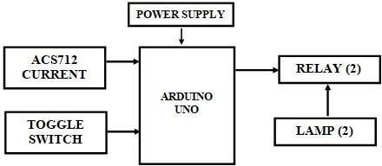

Figure 1 : Detection of power theft

Intimation
The current sensor will automatically send the GPS location to the GSM, which will then send an SMS to the authorized team. The buzzer will be used for indication, and the LCD will be used to display the current status once the current sensor has measured the normal value to the high value

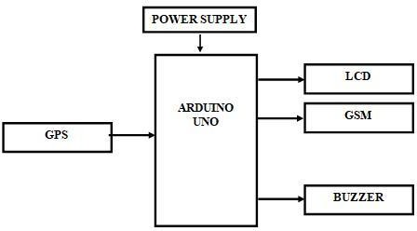

Figure 2 : Intimation of power theft

METHODOLOGY
As technology has advanced, human-machine interaction (HMI) has become more realistic in everyday life. The Internet, which was once used for communication but is now used for things, or the IOT (Internet of Things), is now the focus of HMI research. This application aims to connect anything that can be accessed from anywhere via the Internet. IoT applications can be used in many different areas. It has demonstrated the significant contribution of small-scale applications to large-scale ones, including e-commerce, coal mining [8], wearable devices, the smart grid, laboratory monitoring, agriculture, and a wide variety of other fields. However, we have gotten huge improvements in innovation, yet at the same time, power utilization is one of the enormous issues from one side of the planet to the other. According to the report, Information and Communication Technologies (ICT) alone consume 4.7 percent of the world's electricity, with a possible increase of 10%. This method states that current has been stolen by an illegal customer when there is an increase in current due to the addition of a theft line. The ARDUINO UNO serves as the system's brain. This controls all hardware operations that are interfaced with the controller. The most recent information is updated using the LCD. The GSM will share the authorized team's GPS location in the event of electricity theft, and the current sensor is used to detect the line's current. The lamp is used for indication, and the buzzer will sound when an electricity theft occurs. In this system, if customers or professionals attempt to tamper with the energy meter to reveal low or no energy consumption, the
meter will be closed. One leaf switch is utilized at the establishing aspect of the proposed energy meter to eliminate this issue. The switch's output is connected to the microcontroller's outside interrupt pin. The transfer can be closed under normal circumstances, and the Microcontroller will identify 5V as it's outside interrupt pin. The Microcontroller will detect 0V at its external interrupt pin if the customer attempts to open the energy meter. Assuming this happens, the microcontroller disengages the power right away.
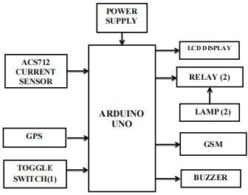
Figure 3 : Block diagram

ALGORITHM IMPLEMENTED
Power theft can be divided into two categories in this paper. A message will be sent to the KEB and the consumer via the GSM module if power theft is detected. The GSM module provides a registered SIM number. The experimental configuration of the proposed system is depicted in figure 4.2. If there is any kind of theft on the distribution lines, a notification should be sent to the electricity office right away. The relay will be used to cut off power when energy consumption exceeds the threshold value. a notification sent to the user informing them that their energy consumption is higher than the threshold value.

RESULT
In the arrangement, there is a bulb that is considered a lawful client. Through a transmission line that runs from a nearby pole, the legal customer is getting electricity or current from the electricity board. By paying the EB their electricity bills, the legal customer consumes electricity legally. The legal customer will not see an increase in their bill or the current value as a result of this. There are certain individuals who unlawfully burglary power from this transmission line by different means. We have added a second bulb to our setup, and it indicates an illegal customer. The unlawful client wrongfully burglary power from the legitimate client bringing about the expanded current bill for them. Therefore, there will be sudden increases in current when the illegal customer attempts to steal current from the transmission line that reaches the legal customer. This sudden increase in current indicates that power has been stolen. Therefore, the power

theft will be displayed on the LCD screen, and a message will be sent to the desired mobile number using the GSM module. We can send the information to the desired mobile number by tracking the exact location of the power theft using GPS. In
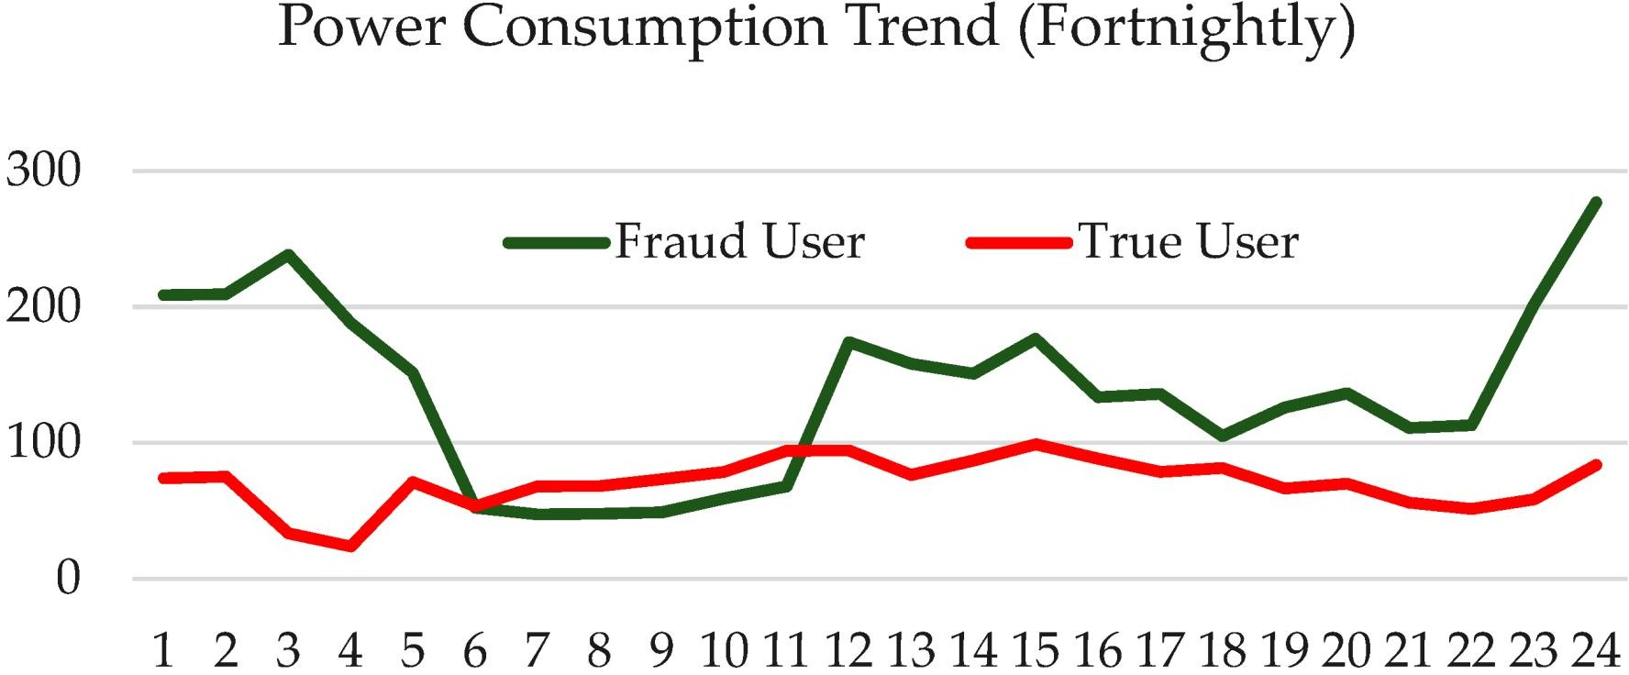
the prototype, we thought about a desired mobile number so that the message could be sent to a nearby EB board or police station in real-time. The ARIMA version provides us with three distinct outcomes.

Figure 4 : Power theft across years

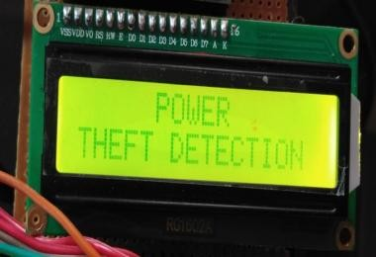

Figure 5 : LCD display

DISCUSSION
The act of stealing electrical power is known as power theft. Power theft costs Indian utility billions of rupees each year. Electricity theft is defined by Section 135 of the Electricity Act of 2003 as the use of electricity for non-authorized purposes, tampering with electricity meters or transformers, tampering with electricity lines, or using a device that makes it difficult to read or damages equipment like electric meters. The electric utility can immediately cut off the supply of electricity if theft of electricity is discovered. The discipline for such offense is "multiple times the monetary benefit because of such robbery of power. If the offense is repeated, the person will not be able to get electricity for at least three months, but it could be up to two years.

CONCLUSION

A CLOF-based approach for AMI electricity theft detection was proposed in this study. This approach calculates the anomaly degree of k-means-selected outlier
candidates by combining LOF and k-means. Additionally, a practical detection framework is being developed. The proposed method performs well in all attack types, except for type 1, according to numerical experiments conducted using a realistic SGCC data set with seven different types of attacks. As a result, when it comes to detecting type MIX that is closer to the actual scene, our method outperforms other methods. The CLOF method has a lot of practical value because there is no one-size-fits-all method for dealing with all types of attacks.

FUTURE SCOPE

This system can be implemented in a high-voltage area with promising futures. It identifies the location of the power theft and immediately informs concerned parties, such as the nearby police station or electricity board, of the location. Squad for detecting theft. This mechanism for theft detection and alerting will be extremely beneficial to industrial consumers like cold storage and ice factories, the plastics industry, the steel industry, and others. Benefits also accrue to high- consumption domestic consumers, such as those who own air conditioners, as well as commercial establishments like cake shops and shopping malls.

REFERENCES

- Q. Chen, K. Zheng, C. Kang, and F. Huangfu, ‘‘Detection methods of abnormal electricity consumption behaviors: Review and prospect,’’ (in Chinese), Automat. Electr. Power Syst., vol. 42, no. 17, pp. 189–199, 2018.
- J. B. Leite and J. R. S. Mantovani, ‘‘Detecting and locating non-technical losses in modern distribution networks,’’ IEEE Trans. Smart Grid, vol. 9, no. 2, pp. 1023–1032, Mar. 2018.
- Northeast Group LLC. (May 2017). Electricity Theft and Non-Technical Losses: Global Markets, Solutions, and Vendors. [Online]. Available: http://www.northeast group.com/reports/Brochure- Electricity%20 Theft %20 &%20 Non-Technical%20Losses%20%20North east%20Group.pdf
- S. Amin, G. A. Schwartz, A. A. Cardenas, and S. S. Sastry, ''Game theoretic models of electricity theft detection in smart utility networks: Providing new capabilities with advanced metering infrastructure,'' IEEE Control Syst., vol. 35, no. 1, pp. 66–81, Feb. 2015.
- Fujian Daily. (2013). The First High-Tech Smart Meter Electricity Theft Case in China Reported Solved. [Online]. Available: http://news. sina.com.cn/c/2013-12- 08/081028915975.shtml
- A. A. Cardenas, S. Amin, G. Schwartz, R. Dong, and S. Sastry, ‘‘A game theory model for electricity theft detection and privacy-aware control in AMI systems,’’ in Proc. 50th Annu. Allerton Conf. Commun., Control, Comput., Oct. 2012, pp. 1830–1837.
- S. S. S. R. Depuru, L. Wang, and V. Devabhaktuni, ‘‘Electricity theft: Overview, issues, prevention and a smart meter based approach to control theft,’’ Energy Policy, vol. 39, no. 5, pp. 1007–1015, 2001.

